Project Planning Phase
Project Planning Template (Product Backlog, Sprint Planning, Stories, Story points)

Date Team ID
Project Name

Maximum Marks

Product Backlog, Sprint Schedule, and Estimation (4 Marks)
Use the below template to create product backlog and sprint scheme
Sprint | Functional Requirement (Epic) | User Story / Task | Story Points | Priority | Team Members
Sprint-1 | Resources Initialization | Create and initialize accounts in various public APIs like OpenWeatherMap API. | 1 | LOW | Pavithra Rohini  Naresh Kumar Mallisri
Sprint-1 | Local Server/Software Run | Write a Python program that outputs results given the inputs like weather and location. | 1 | MEDIUM | Pavithra Rohini  Naresh Kumar Mallisri
Sprint-2 | Push the server/software to cloud | Push the code from Sprint 1 to cloud so it can be accessed from anywhere | 2 | MEDIUM | Pavithra Rohini  Naresh Kumar Mallisri
Sprint-3 | Hardware initialization | Integrate the hardware to be able to access the cloud functions and provide inputs to the same. | 2 | HIGH | Pavithra Rohini  Naresh Kumar Mallisri
Sprint-4 | UI/UX Optimization & Debugging | Optimize all the shortcomings and provide better user experience. | 2 | LOW | Pavithra Rohini  Naresh Kumar Mallisri
15 November PNT2022TMID44492
Signs with Smart Connectivity for Better Road Safety
8 Marks
2022

Project Tracker, Velocity & Burndown Chart: (4 Marks)

Velocity:

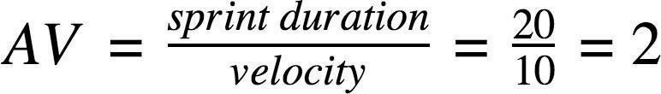
Imagine we have a 10-day sprint duration, and the velocity of the team is 20 (points per sprint). Let’s calculate the team’s average velocity (AV) per iteration unit (story points per day)
Sprint | Total Story Points | Duration | Sprint Start Date | Sprint End Date (Planned) | Story Points Completed (as on Planned End Date) | Sprint Release Date(Actual)
Sprint-1 | 20 | 6 Days | 24 Oct 2022 | 29 Oct 2022 | 20 | 29 Oct 2022
Sprint-2 | 20 | 6 Days | 31 Oct 2022 | 05 Nov 2022 | 20 | 31 Oct 2022
Sprint-3 | 20 | 6 Days | 07 Nov 2022 | 12 Nov 2022 | 20 | 07 Nov 2022
Sprint-4 | 20 | 6 Days | 14 Nov 2022 | 19 Nov 2022 | 20 | 14 Nov 2022

Burndown Chart:

